**附件1：推荐荐文**

**1.中国风物 Chinese Cultural Icons 屈原与九畹溪的兰花Qu Yuan and the Orchids of Jiuwan Stream**

——《用英语讲中国故事》基础级 P008

The story goes that when the poet Qu Yuan (屈原) was banished by King Huai of Chu due to the machinations of the king's evil ministers, he took his beloved orchids and bamboo-strip books, and set up a school on Fairy Mountain. One day, the Orchid Goddess of Fairy Mountain, while floating on a cloud, happened to pass a thatched cottage. Inside, Qu Yuan was teaching a class, vigorously promoting righteous conduct for the Kingdom of Chu. The goddess stood outside the window quietly listening, particularly impressed by the poet’s deeply-felt patriotism. She knew that Qu Yuan had always loved orchids, so before she left she endowed three orchids which Qu Yuan had planted under the window with supernatural power.

相传，屈原遭奸臣陷害被楚怀王放逐，带着他心爱的兰花和书简在仙女山上办起了学堂。一天，仙女山的兰花娘娘云游路过一间茅舍，正好发现屈原讲课，于是站在窗外静静地听。屈原正慷慨激昂地向学生们讲授振兴楚国的道理。屈原那赤诚的爱国深情令兰花娘娘特别感动。她知道屈原向来喜欢兰花，临走时便将屈原栽种在窗下的三株兰花点化成精。

**2.中国习俗 Chinese Customs 未了的乡愁 Lingering Nostalgia**

——《用英语讲中国故事》提高级 P062-063

As a teenager, Yu Guangzhong would follow his parents to many places of interest in the historic city. On their return from the Sun Yat-sen Mausoleum, his father asked him: “Do you know whose tomb it is?”

“That’s easy,” he replied. “It is Dr. Sun Yat-sen’s.”

“Correct,” his father said, and continued, “So who was Sun Yat-sen?”

“He was a great pioneering revolutionary who proposed the Three Principles of the People, and the founder of the Republic of China!” Yu answered promptly. His father, giving him a thumbs-up, found that, as well as literary talent, his son was also good at political and historical knowledge. He believed that only with extensive reading could this be acquired, and now he was relieved.

余光中少年时代，父母经常带着他到处走走看看。南京是座历史文化名城，很多地方都留下了余光中的足迹。有一次，父亲带他去了中山陵。在回家的路上，父亲想考考余光中。他问余光中：“你知道中山陵是谁的陵寝吗？”“爸爸，这个你可难不倒我。是孙中山先生的！”“那么你说说孙中山先生是什么人？他有什么贡献？”父亲接着问。“他是伟大的民主革命先行者，提出了‘三民主义’，也创造了中华民国！”余光中自信地回答。父亲为余光中竖起了大拇指。他知道儿子从小情感细腻，有很强的文学天赋，但政治历史方面怎么样还真拿不准。看来，孩子平时没少看这方面的书，父亲欣慰地笑了。

**3.中国人物 Chinese Sages and Great Figures 老子身上的中国智慧 Origin of Chinese Wisdom**

——《用英语讲中国故事》熟练级 P127

Laozi asked Confucius: “Why don't you learn from the noble virtue of water?” Confucius said, “What virtue does water have?” Laozi said, “Nothing else in the world has the supreme goodness of water. Water is the source of life, nourishing everything and producing all kinds of life. It gives nutrition to life without taking anything from it. This is the virtue of modesty. Water flows from high places to low places, and stays in lower places that others shun. It bears heavy burdens, stays humble and helps others. This is the virtue of kindness. Water is the softest thing in the world. It does not even have a fixed form, but can adapt to the shapes of all kinds of containers. It can open channels in soil and rock one hundred times harder than itself. The soft overcomes the hard, and the weak conquers the strong. This is the virtue of gentleness and tenacity found in water.”

老子问孔子“你为何不学学水的高尚品格呢？”孔子说：“水有什么品格呢？”老子说:“天下最善的莫过于水了，水是生命之源，滋润万物，哺育了各式样的生命，自己却只给予生灵养分而不会从它们身上为自己争些什么，这是其谦虚的美德；水由高处向低处流，最终停留在众人不喜欢的卑下的地方，还要忍辱负重、帮助别人，这是其善良的美德；水是世间最柔软之物，甚至没有固定的形态，但能够适应各种容器的形状，还能在比自己坚硬百倍的土壤、岩石上开辟出通路以柔克刚、以弱胜强，这是其柔和坚韧的品格。”

**4.中国成就 Chinese Achievements 屡创“世界第一”的港珠澳大桥 The Hong Kong-Zhuhai-Macao Bridge**

——《用英语讲中国故事》基础级 P204

After innumerable difficulties had been overcome, on July 7, 2017 the Hong Kong-Zhuhai-Macao Bridge was fully opened. Seen from the air, the winding bridge looks like a long dragon. From Zhuhai Bay, the bridge stretches for over thirty kilometers above the sea, together with six-point-seven kilometers of tunnels under the seabed, to end in Hong Kong. On the way, there are three specially modeled cable-stayed bridges, named “China Connection,” “Dolphin” and “Sail,” respectively, capable of sustaining a total of three hundred thousand tons of wheeled cargo.

Su Quanke remarked, “The bridge not only links the three geographical regions, it also forms a link between our thoughts and feelings, including the creative superiority we have developed over centuries.”

工程师们克服了一个又一个难题，港珠澳大桥于2017年7月7日实现了全面贯通。从空中俯瞰大桥，那逶迤的桥身如一条长龙，从珠海洪湾这端起，穿行三十多公里后消失于海中，经过海底 6.7公里的隧道穿行，再次跃出水面，直达香港。同时，桥身上还建设了“中国结”“海豚”“风帆”三座造型独特的斜拉桥，三十万吨巨轮也能顺利通过。

正如苏权科所言：“它不仅把三地的地理联系起来了，它把我们的思想感情，包括我们几百年来创造的优势的东西都能够联系起来了。”

**5.中国艺术 Chinese Arts 高山流水遇知音 Classical Music: Story of Mountains and Streams**

——《用英语讲中国故事》提高级P285

Delighted, Bo Ya followed his teacher on a boat, his zither on his back, to Mount Penglai by the East Sea. Upon arrival, his instructor told Bo Ya to rest, and then sought the immortal guidance. After waiting amidst the towering mountains and green fields for a long time, Bo Ya set off in search of his instructor. As his path rounded a peak, he was startled by the marvelous scene before him. A crystal-clear waterfall revealed itself from the mists, the water splashing like pearls with hauntingly beautiful melodies never heard on Earth before. Inspired, Bo Ya sat and played a fabulously intoxicating tune. He was lost in his music until his teacher laughed behind him: “Ha! I see that you’ve found the immortal guidance!”

一天，老师对伯牙说：“我带你去寻一个仙师点化点化，好吗？”伯牙高高兴兴地背着琴随老师乘船来到东海蓬莱山。老师让他坐地休息，自己去找仙师去了。伯牙在这巍峨苍郁的山野中，久等不见老师归来，便沿一条山路寻去。绕过一个山头之后，不想却有一幅奇景出现在眼前：云中见飞瀑，雾中流清泉，水花四溅似珍珠，水声回荡如仙乐。伯牙顿时灵感涌起，便席地而坐，抚琴而成妙曲，陶醉其间。突然，他的身后传来老师的声音：“哈哈，哈哈……仙师被你找到了。”

**6.中国精神 Chinese Spirit 平凡岗位上的不平凡奉献 Train Ticket Seller Sun Qi**

——《用英语讲中国故事》熟练级 P390

Sun smiled at all the people who came to her window, believing that her smile could make them feel friendly. For that purpose, she specially put a mirror on her desk to remind herself to keep a smiling face at all times. It might be quite easy to smile at one passenger, but when Sun had to handle nearly 2,000 travelers every day, it was remarkable for her to keep a smiling face for all of them. In fact, she didn’t need to do that in her work; she did it just to make the passengers feel at home. Working in the service industry, Sun considered it her highest goal to make the passengers as satisfied with her work as possible.

微笑能够让人觉得温暖，这就是孙奇选择对每一位前来购票的乘客保持微笑的原因。为了做到这一点，她特地在桌子上放了一面镜子，时时刻刻提醒自己保持笑容。一个人，一张车票，保持微笑接待不算太难，可孙奇一天要卖出将近两千张车票，对每个人都保持着微笑，是一件非常不可思议的事情。其实没有什么规定要求她这样做，可孙奇就想把自己的工作做到最好，让来往的乘客感到温暖。作为服务行业的从业人员，她在工作中的最高目标就是能够让乘客更满意。

**7.兵马俑 世界第八大奇迹Terracotta Warriors The Eighth Wonder of the World**

——《陕西：中华文明的肇始之地》（英文版）P10

More than 2,000 years ago, Ying Zheng, the First Emperor of Qin, who had swept away rival states and unified all states in one China, attached great importance to the construction of his mausoleum. After inspecting many places and taking feng shui into account, he finally chose a site at the foot of Lishan Mountain.

He appointed Li Si, the prime minister, to oversee the planning and design of the mausoleum and recruited skilled craftsmen from all over the country to build a huge army of terracotta figures, not only with soldiers, but also with war horses, chariots and real weapons, which had to be made life sized.

According to the system used at that time, the names of the artisans who made the terracotta figures were also engraved on the body, thereby enabling inspectors to check the work of the artisans, eliminating substandard products and improving efficiency and quality.

——《陕西：中华文明的肇始之地》（中文版）P9

2000 多年前，一扫六合、统一中国的秦始皇嬴政十分重视自己的陵墓修建。他考察了许多地方后，最后看中了骊山脚下的这块风水宝地。

秦始皇任命李斯主持陵墓的规划设计，并征调全国的能工巧匠，烧制规模庞大的陶俑军队，不仅要有军士，还要有战马、战车、兵器，并要求必须按原物的真实大小进行制作。

陶俑身上还刻有制作工匠的名字，这是秦国当时的一项制度，即器物的制造者必须把自己的名字刻在上面，供管理者检查。这样可以杜绝以次充好的现象，提高生产效率和质量。

**8.面条像裤带 奇字奇面 Biangbiang Noodles A Fantastic Dish with a Fantastic Name**

——《陕西：中华文明的肇始之地》（英文版）P50

The owner of the small food stall was an old man, graying at the temples but with a booming voice and nimble with his hands. Grasping two ends of a piece of dough, then throwing and beating it hard on the chopping board, he would loudly greet customers.

With his pulling, stretching, throwing and beating, the dough became wide and long, just like a “trouser belt.” The belt-like noodles flew into the air from the old man’s hands, took a U-turn and were pulled back, over and over again. After being thrown hard on the board with a “biang-biang” noise a few times, the noodles were dropped in the big iron pot of boiling water. As the belt-like noodles were roiling in the water, a ladle of cold water was poured over them, and the white noodles immediately became fine, bright and almost transparent.

——《陕西：中华文明的肇始之地》（中文版）P42

店家是一位老汉，虽两鬓斑白，但声音洪亮、手脚利索，一边揪住面剂子的两头在案板上使劲地摔打，一边吆喝着，很是风光。

在拉、扯、摔、绊之间，面剂子变得又宽又长，像裤带一样，从老汉的手中飞向空中，又扭转着拉扯回来，在案板上“biang biang”几下，然后准确地落在翻滚冒气的大铁锅里。面条在开水中不断翻滚，老汉加一瓢凉水，白色的面立即发亮透明起来。

**9.曾国藩 洋务运动的先驱者 Zeng Guofan Pioneer of the Self-Strengthening Movement**

——《湖南：惟楚有才，于斯为盛》（英文版）P99

On the fourth day of the seventh lunar month, 1862, the weather was exceptionally clear. A boat floated on the Yangtze River outside Anqing city. With a deck and hull of wood, it resembled traditional sailboats. It was powered, however, by China’s first steam engine. Its structure resembled the foreign “reciprocating steam engine,” where the steam from the boiler entered the cylinder, and the piston movement drove the wheels’ rotation. Sailors on the river were astonished to see the small steamboat emitting smoke and traveling at an incredible speed with no sails. Zeng was elated by the successful trial run, writing in his diary: “The intelligence, wisdom, and craftsmanship of the Chinese are in no way inferior to those of foreigners.”

——《湖南：惟楚有才，于斯为盛》（中文版）P100

清同治元年（1862年）农历七月四日，天气十分晴朗。安庆城外的长江水面上，漂浮着一艘木壳轮船。这艘轮船的船板、船舷都是木质的，看起来与长江上来往航行的帆船区别不大，但是却没有挂上船帆，而是安了一架奇怪的机器，这就是中国人研制的第一台蒸汽机。它的结构与外国新型的“往复式蒸汽机”相类似，当锅炉中的蒸汽进入汽缸后，活塞运动就能带动圆轮旋转。江面上其他帆船上的人，都惊奇地看着这艘冒着烟的小轮船，没有张挂帆布却航行如飞，觉得非常不可思议。曾国藩看到小轮船试航成功，心情十分激动。他在日记中写道：“窃喜洋人之智巧，我中国人亦能为之”

**10.湘绣 以针代笔的艺术Xiang Embroidery Using Needles to Create Artworks**

——《湖南：惟楚有才，于斯为盛》（英文版）P63

Li was an expert in poetry, painting, and embroidery. She had invented a new embroidery technique that captured the various moods of Chinese landscape paintings. By separating embroidery threads into finer and finer strands, leaving gaps at color changes, and using uneven stitches to blend different colors and shades one stitch at a time, she invented a new technique which became known as "blended needlework." It solved the problem of rigid color transitions and lack of vividness that had long plagued the art.

——《湖南：惟楚有才，于斯为盛》（中文版）P62

李仪徽精通诗书和绘画，平日里也喜欢钻研刺绣技能用以自娱。为了用刺绣表现中国山水画蕴含的恬淡、清雅等各种意境，她经过无数次试验，找到了一种新的技法。她将刺绣丝线分了又分，以至于比头发丝还细。在需要交换颜色的地方，又留出空隙，用长短不齐的针脚，将不同颜色和色级的丝线搭配，一针一针掺进去。这种方法，正是后来名声大噪的掺针法。有了这个新技法，以往刺绣界颜色过渡生硬、形象不够生动的难题得以解决。

**11.追求卓越 永无止境的创新动力 Shanghai Academy of Spaceflight Technology Pursuing Excellence in Aerospace Innovation**

——《上海：兼收并蓄的活力之都》（英文版）P196

SAST is an organization under China Aerospace Science and Technology Corporation. Its CZ-6 isn’t just an ordinary member of the Long March family—it is its family. In 2015, the debut launch of the CZ-6 drew global attention with its amazing launch of twenty satellites with one rocket. For the first time, it used a high-pressure, high-thrust, non-toxic, pollution-free, staged combustion cycle engine fueled by kerosene and liquid oxygen developed and manufactured in China, inaugurating the operation of China’s new-generation of carrier rockets.

On November 21, 2017, the CZ-6 carried out its second flight, sending the Jilin-1 Video 04, 05, and 06 satellites into space, becoming China’s first new-generation carrier rocket to carry out a commercial launch.

——《上海：兼收并蓄的活力之都》（中文版）P164

长征六号运载火箭可不是“长征”火箭家族中平平无奇的一员，它是这个家族的拓路者。2015 年，长征六号一经亮相就以“一箭 20 星”的亮眼成绩吸引了全世界的目光。它首次采用了中国研制的高压、大推力、无毒、无污染的液氧煤油补燃循环发动机，拉开了中国新一代运载火箭投入使用的序幕。2017 年 11 月 21 日，长征六号火箭第二次发射，以“一箭三星”方式将“吉林一号”视频 04、05、06卫星发射升空，成为中国新一代运载火箭中首枚参与商业发射的火箭。

**12.江南制造局 中国民族工业的摇篮 The Jiangnan Shipyard The Cradle of Chinese National Industry**

——《上海：兼收并蓄的活力之都》（英文版）P138

In the following decades, the Jiangnan Machine Works made remarkable achievements and quickly became the birthplace of modern Chinese industry. As “China’s first factory,” the Jiangnan Machine Works created many “firsts,” such as the first lathe, the first steel, the first rifle, the first cannon, the first steam-powered warship, and the first ironclad warship. Driven by the Jiangnan Machine Works, one after another national enterprises and modern schools were built nearby, making Zhizaoju Road a thriving area of Shanghai. But at the time the Qing government was too far gone, and there were also problems with this Works itself: compared to its foreign counterparts, it had higher production costs but produced less advanced weapons and suffered from internal corruption. So in the end, the Self-Strengthening Movement, epitomized by the Jiangnan Machine Works, wasn’t able to turn the tide and create a new beginning for China.

--《上海：兼收并蓄的活力之都》（中文版）P166

作为“中国第一厂”，江南制造局生产了中国第一台车床、第一支步枪、第一门钢炮、第一艘蒸汽动力军舰、第一艘铁甲军舰。在江南制造局的带动下，周边陆续建起了许多民族企业和新式学堂，制造局路因此成为上海的兴旺繁华地带。但是，此时的清政府已病入膏肓，江南制造局的枪炮生产成本高，质量也赶不上国外更先进的武器装备，制造局内部也存在贪腐的弊病，以自强求富为目的的洋务运动，最终未能挽大厦于将倾。

**附件2：朗诵素材范围参考**

选手可在《用英语讲中国故事》系列（基础级、提高级、熟练级）或“故事里的中国”系列（《陕西：中华文明的肇始之地》、《湖南：惟楚有才，于斯为盛》、《上海：兼收并蓄的活力之都》）中任选篇目和段落完成朗诵作品。

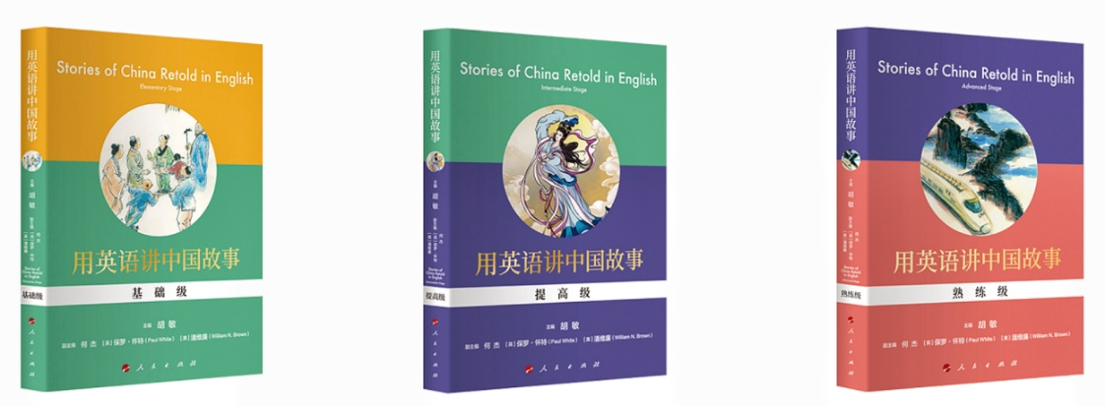

《用英语讲中国故事》丛书由新航道国际教育集团组织国内教育界、翻译界权威专家编写，人民出版社出版。丛书从中国风物、中国习俗、中国人物、中国成就、中国艺术、中国精神六大领域选择最具中国特色的故事200余个。采用汉英对照形式，分为基础、提高、熟练三个级别，通过不同级别内容的变化，帮助青少年中英文阅读和写作能力双重提升。同时，这也是一系列向世界介绍中国的通俗读本。通过阅读本系列丛书，读者可对中国文化概貌有大体了解，真正实现用英语讲好中国故事。

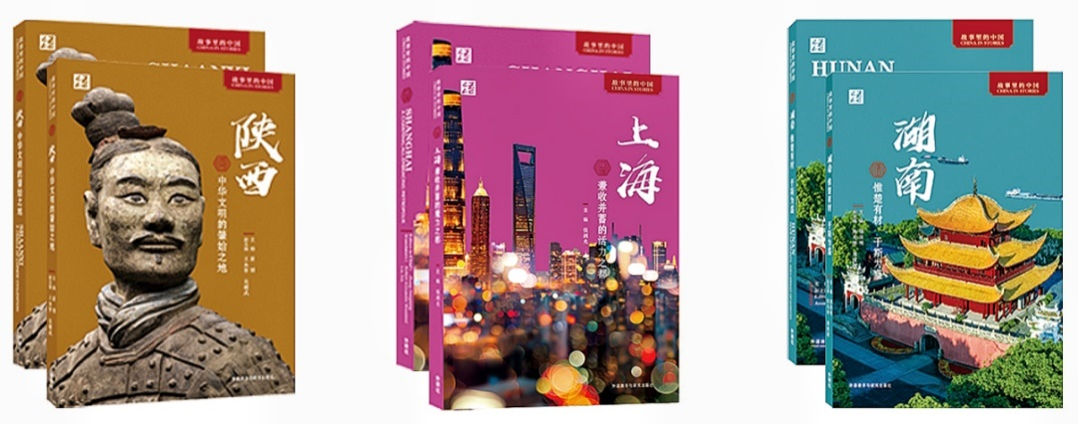

“故事里的中国”丛书由教育部中外语言交流合作中心联合新航道国际教育集团共同策划，外语教学与研究出版社出版。丛书按照中国34个省级行政区进行分卷编撰，每卷展示故事50个左右，中英双语出版，面向海内外青少年读者。目前已陆续出版《陕西：中华文明的肇始之地》《湖南：惟楚有才，于斯为盛》《上海：兼收并蓄的活力之都》。

丛书围绕“地方风物、地方习俗、地方艺术、地方成就、地方人物、地方精神”六大主题，来呈现不同省份独特的历史文化和社会生活。旨在通过“小切口”呈现“大视野”，以更加接地气的方式讲好每个省的故事，既展现具有地域特色的中华传统文化，又反映新时代风貌和中国各地区各领域的发展成就。用融通中外的语言展现可信、可爱、可敬的中国形象，帮助广大青少年了解家乡、热爱家乡、推广家乡。

如需购买图书可扫描下面二维码，图书均含所有文章对应音频。

